<https://github.com/sophiedamato/cs130/settings/pages>

<https://sophiedamato.github.io/cs130/>

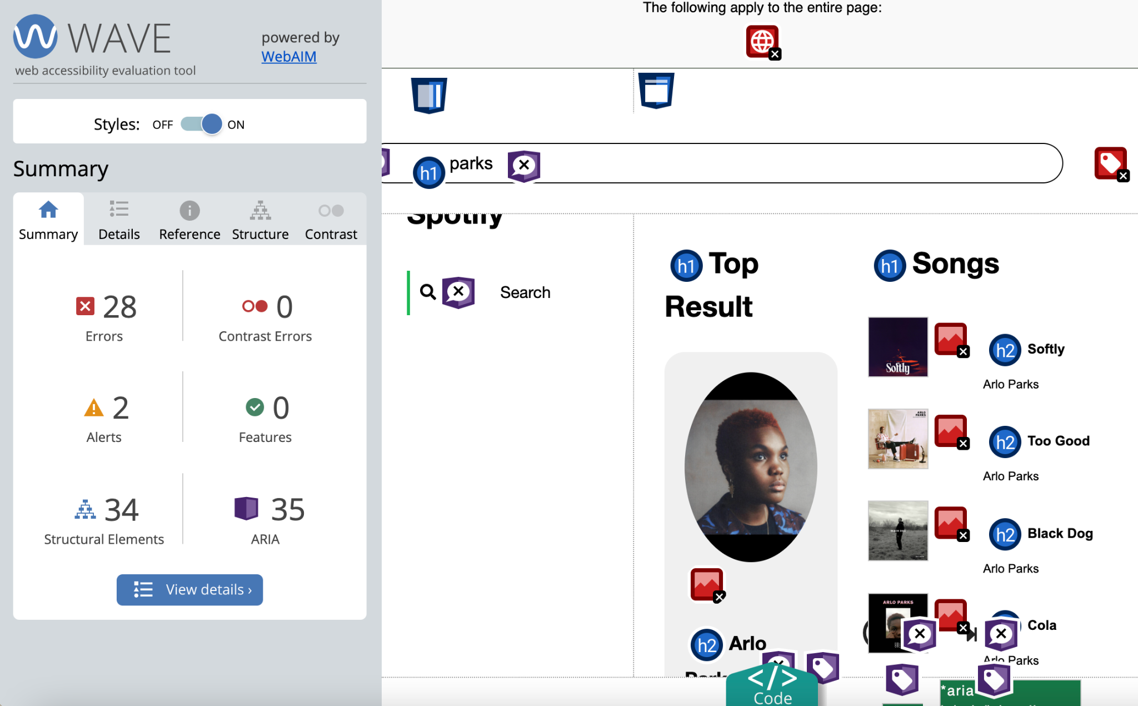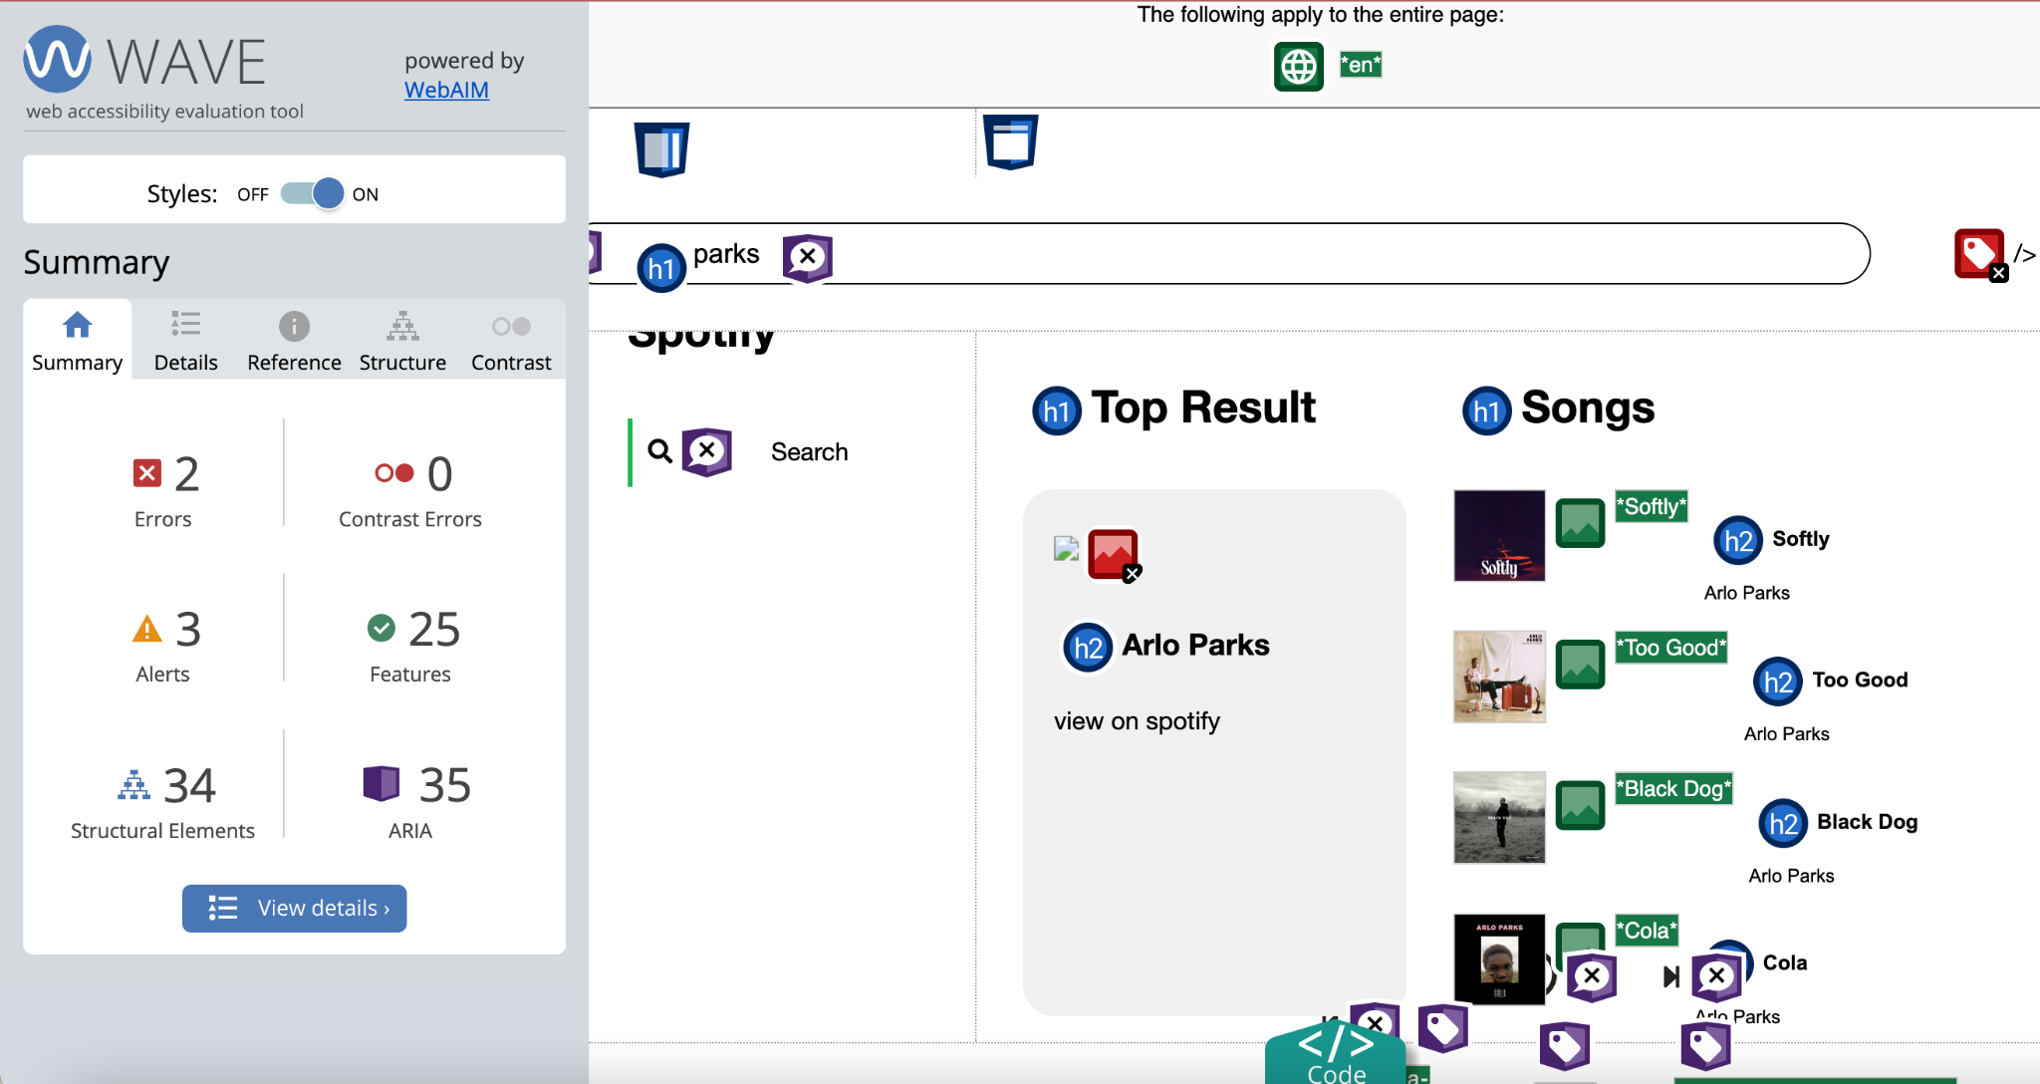

Unfortunately, I wasn’t able to correct all error codes, but considering I started with 28, I was happy with the result. I tried for a while to figure out how to add alt text to the remaining image, but for some reason, the image itself disappeared and I wasn’t able to get it back after undoing my work. In addition, I tried adding the “missing form label” to the search bar by adding an “aria-label” attribute but was unable for it to be registered in the WAVE analysis. I left these additions in my respective HTML and JavaScript areas, so maybe you might be able to figure out why the image disappeared?

Yes! When tabbing through the interface, I am able to search for an artist, select a song, and then place the song.

I’m not sure of any other accessibility check features at the moment…